**Rhonda Dredge Australian Arts Review**

<https://artsreview.com.au/the-waywardness-of-the-sisterhood/>

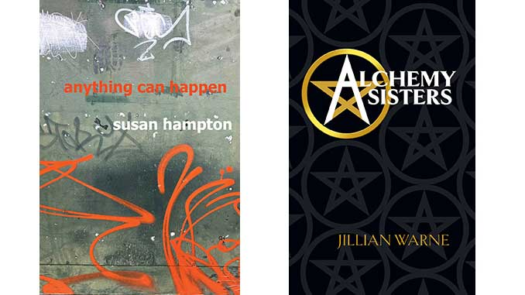

Writing is a radical activity articulated by two recent books by women to help explain their lives to themselves, one muted, the other colourful.

Susan Hampton won a Victorian Premier’s Literary Award for her memoir and Jillian Warne has just released her debut novel. Both Anything Can Happen and Alchemy Sisters deal with the waywardness of the sisterhood.

Hampton grew up in Stockton, a suburb of Newcastle, in a family of fishermen and BHP workers. There was a lot of drinking, wife-bashing and little self-reflection.

Warne lives in south-west Victoria and her novel deals with the loneliness, low feelings of self-worth and tedium for older, intelligent women who have accepted society’s projections.

She takes four characters, complex on the inside, and gives them new roles in a life of crime that suit their personalities, converting complaints into get-rich schemes.

“I became more aware of the community perception of older women,” Warne told AAR. “I wanted to use that invisibility to advantage.”

When Hampton set out on her journey to be a writer she knew she wasn’t attracted to boys, she had never heard the word lesbian and she spent most of her time fishing and cuddling up, embarrassingly, with a neighbouring woman.

She always had a writer’s sense of curiosity and some of the best parts of her book involve getting her 80-something uncle to finally fess up about his personal life.

Her uncle admitted that he had abandoned his wife and their small children yet, in a sweep of patriarchal superiority, called his sons no-hopers for never leaving home.

Hampton moved around a lot with many heartbreaks and a feast of parties and happenings, but not much stability. At one stage she bought land at Majorca, a tiny settlement in Central Victoria.

What kept her going through a short marriage, raising a son and the meanderings was her writing, with university posts and grants for both her poetry and prose. She didn’t settle down until middle-age, rough sleeping in an abandoned boat house in Sydney for some of that time.

Warne’s is a more dramatic response to the underestimation of women’s skills. One of her characters picked up ten languages on the boat out from Europe and forged connections to the mafia; another had the equipment to melt down gold in her shed.

Together, the sisters are able to outsmart police, steal jewellery and carry out some daring heists in an amusing romp that demonstrates how fiction works to bedazzle, particularly in a small country town.

The path to literary fulfilment is never dull as these writers dig into their lives for telling detail. Warne has a flair for a dramatic pose, such as the break-in at the local police station, while Hampton returns to the same material over and over in a mesmerising manner, detail slowly building up the pictures of her life as she questions memories

She claims to have always been worried about being an unreliable narrator. “I have to watch myself and the seemingly inborn desire to decorate or embellish a story,” she writes.

Do these embellishments give life a lift above the sanitised blow-by-blow accounts of the typical realist plodder or is the irony of understatement the true jewel in a story?

Anything Can Happen, Susan Hampton, 2024, is available from [Puncher & Wattman](https://puncherandwattmann.com/product/anything-can-happen/) | Alchemy Sisters, Jillian Warne, 2024, is available from [www.jillianwarne.com](https://www.jillianwarne.com/)

***Images:*** Anything Can Happen (book cover) | Alchemy Sisters (book cover)

***Words:*** Rhonda Dredge